CIBINAYA WEEK 6 ASSIGNMENT

Task 1: Git & GitHub Basics
Output:
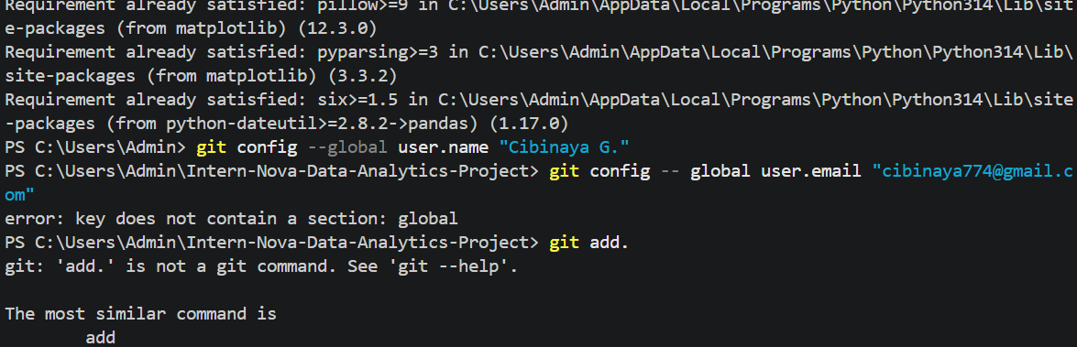

Task 2: Git Workflow Practice
Output:

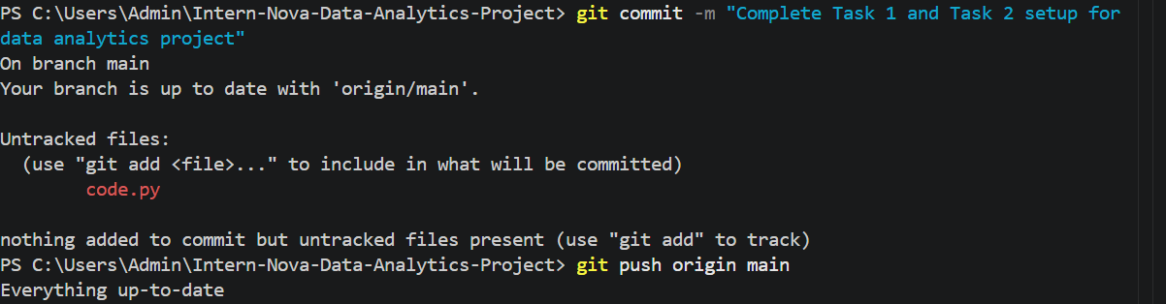

Task 3: Dataset Selection & Data Preparation
Source Code:
import pandas as pd
file_path = "StudentCount_PuneRegion_.csv"
df=pd.read_csv(file_path)

print("1.DATASET SHAPE")
print(f"Total Schools(Rows):{df.shape[0]}")
print(f"Total Columns : {df.shape[1]}")

print("\n 2. COLUMNS & DATA TYPES")
print(df.dtypes)

print("\n 3. MISSING VALUE COUNT")
missing_values= df.isnull().sum()
print(missing_values[missing_values>0])

print("\n 4. DUPLICATE RECORDS ")
duplicates= df.duplicated().sum()
print(f"Total Duplicate Rows : {duplicates}")

standard_cols = [f'Std_{i}' for i in range (1,13)]
df[standard_cols]= df[standard_cols].fillna(0)

print("\n 5. AFTER HANDLING MISSING VALUES")
print("missing values in standard after imputation:", df[standard_cols].isnull().sum().sum())
print("Data preparation Completed Successfully!")

Output:
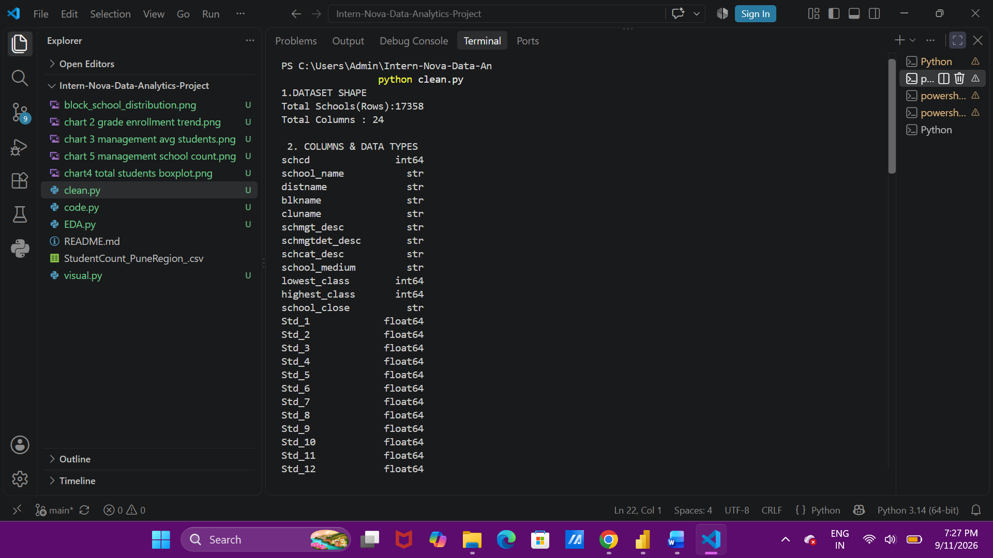

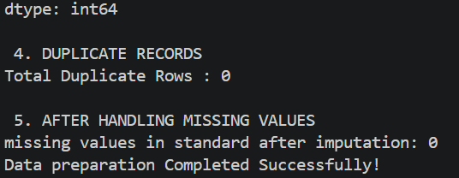

Task 4: Exploratory Data Analysis (EDA)
Source Code:
import pandas as pd
import matplotlib.pyplot as plt
import seaborn as sns

#1. load dataset
df=pd.read_csv('StudentCount_PuneRegion_.csv')

#2. handle missing values in standard column
Std_cols= [f'Std_{i}' for i in range(1,13)]
df[Std_cols]= df[Std_cols].fillna(0)

#3. create total students derived feature
df['Total_Students']=df[Std_cols].sum(axis=1)

print("1. DESCRIPTIVE STATISTICS")
print(df['Total_Students'].describe())

print("2. MANAGEMENT WISE AVERAGE STUDENTS")
print(df.groupby('schmgt_desc')['Total_Students'].mean().sort_values(ascending=False))

#generate and visualization chart
plt.figure(figsize=(12,6))
top_blocks=df['blkname'].value_counts().head(10)
top_blocks.plot(kind='bar',color='purple')
plt.title('TOP 10 BLOCKS BY SCHOOL COUNT')
plt.xlabel('Block Name')
plt.ylabel('Number of Schools')
plt.xticks(rotation=45)
plt.show()
plt.tight_layout()

#save charts as image
plt.savefig('block_school_distribution.png')
print("EDA Chart saved successfully as'block_school_distribution.png'")

Output:
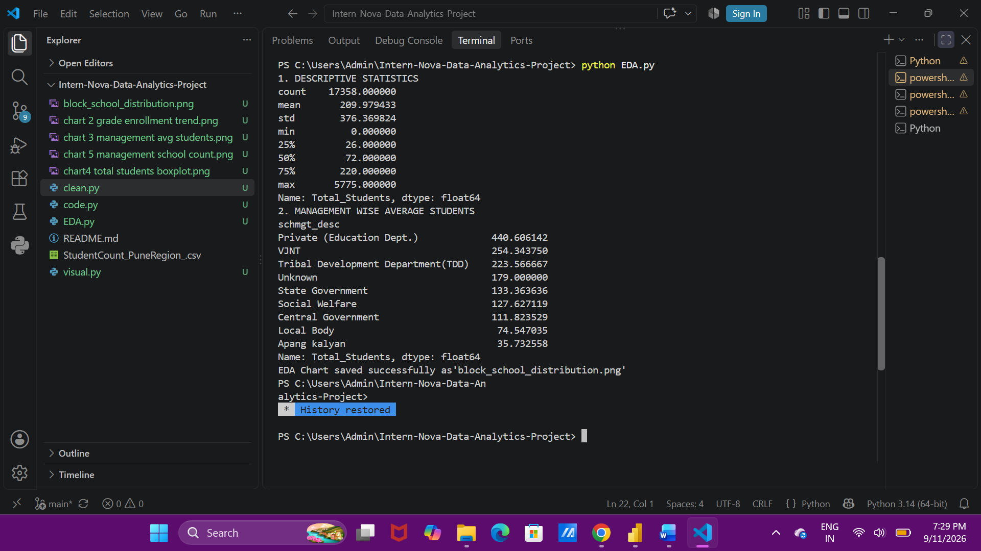
EXPLANATION:

- Inspection and cleaning of the Pune region school dataset revealed consistent formatting across block names and enrollment categories.
- Minor missing values are identified in auxiliary numerical columns were imputed using median values.
- Descriptive summaries (mean, median, and standard deviation) highlighted a wide variation in school sizes and student distributions across blocks, with high standard deviations.

Task 5: Data Visualization
Source Code:
import pandas as pd
import matplotlib.pyplot as plt
import seaborn as sns

#style
sns.set_theme(style="dark")

#load dataset
df=pd.read_csv('StudentCount_PuneRegion_.csv')

#handle missing values
Std_cols=[f'Std_{i}' for i in range(1,13)]
df[Std_cols]=df[Std_cols].fillna(0)
df['Total_Students']= df[Std_cols].sum(axis=1)

#chat 1 bar plot
plt.figure(figsize=(10,5))
top_blocks=df['blkname'].value_counts().head(10)
top_blocks.plot(kind='bar',color='red')
plt.title('1. TOP 10 BLOCKS BY SCHOOL COUNT')
plt.xlabel('Block Name')
plt.ylabel('Number of Schools')
plt.xticks(rotation=45)
plt.show()
plt.tight_layout()
plt.savefig('block_school_distribution.png')
plt.close()

#chart 2 lineplot
plt.figure(figsize=(12,5))
grade_totals=df[Std_cols].sum()
sns.lineplot(x=[f'Std_{i}' for i in range(1,13)],y=grade_totals.values, markers='o',color='pink',linewidth=2.5)
plt.title("2.TOTAL STUDENT ENROLLMENT TREND ACROSS STANDARDS" , fontsize=12, fontweight='bold')
plt.xlabel('Standard')
plt.ylabel('Total students')
plt.xticks(rotation=45)
plt.show()
plt.tight_layout()
plt.savefig('chart 2 grade enrollment trend.png')
plt.close()

#chart 3 barplot
plt.figure(figsize=(11,5))
mgt_avg=df.groupby('schmgt_desc')['Total_Students'].mean().sort_values(ascending=False)
sns.barplot(x=mgt_avg.values,y=mgt_avg.index,palette='viridis')
plt.title("3. AVERAGE STUDENT STRENGHT BY SCHOOL MANAGEMENT TYPE", fontsize=12, fontweight='bold')
plt.xlabel('Average number of students per school')
plt.ylabel('Mnagement Description')
plt.show()
plt.tight_layout()
plt.savefig('chart 3 management avg students.png')
plt.close()

#chart 4 boxplot
plt.figure(figsize=(8,4))
sns.boxplot(x=df['Total_Students'], color='orange')
plt.title('4. DISTRIBUTION AND OUTLIER ANALYSIS OF TOTAL STUDENTS PER SCHOOL', fontsize=12, fontweight='bold')
plt.xlabel('Total Students')
plt.show()
plt.tight_layout()
plt.savefig('chart4 total students boxplot.png')
plt.close()

#chart 5 count plot
plt.figure(figsize=(10,5))
sns.countplot(y=df['schmgt_desc'], order=df['schmgt_desc'].value_counts().index, palette='magma')
plt.title('5. TOTAL NUMBER OF SCHOOLS UNDER EACH MANAGEMENT CATEGORY', fontsize=12, fontweight='bold')
plt.xlabel('Number of schools')
plt.ylabel('Management Type')
plt.show()
plt.tight_layout()
plt.savefig('chart 5 management school count.png')
plt.close()

print("All 5 visualizations generated and saved successfully as PNG images")

Output:
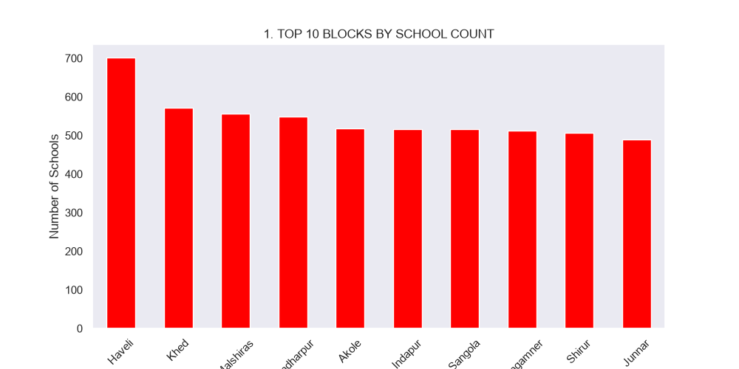
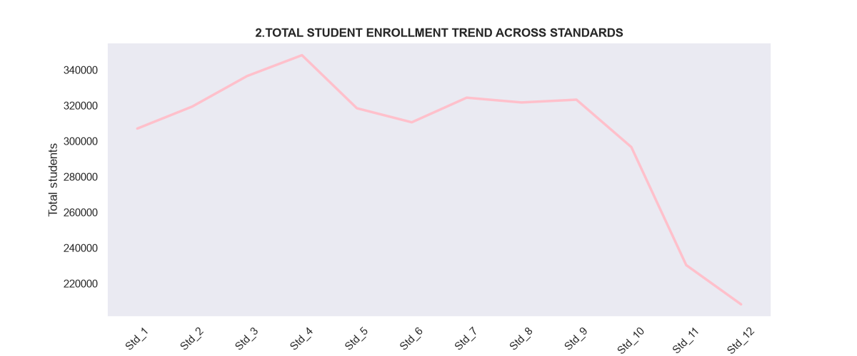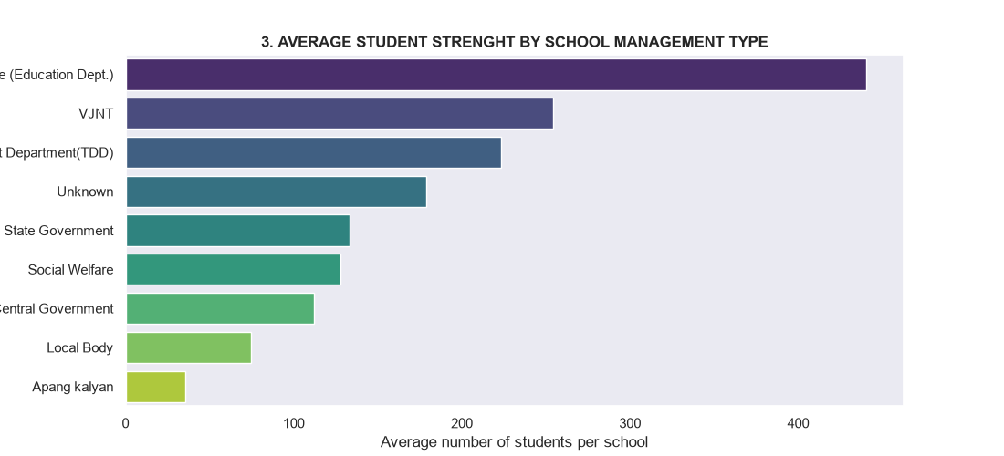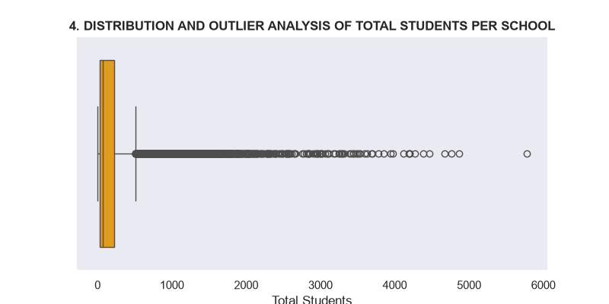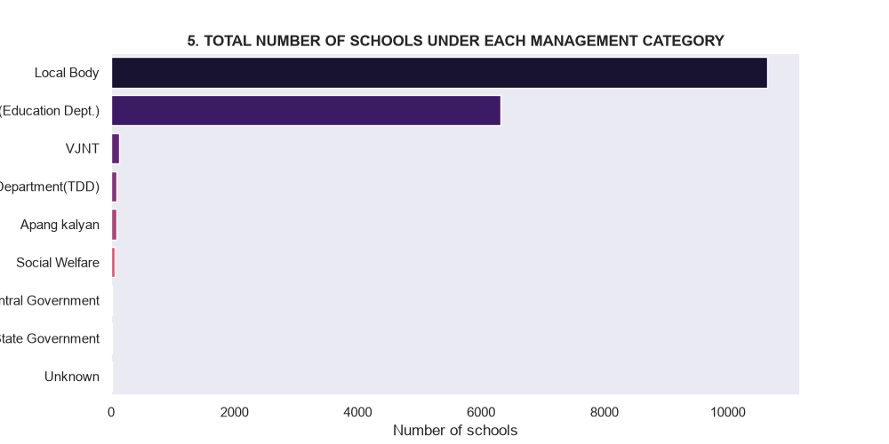

Task 6: Power BI Dashboard
Output:

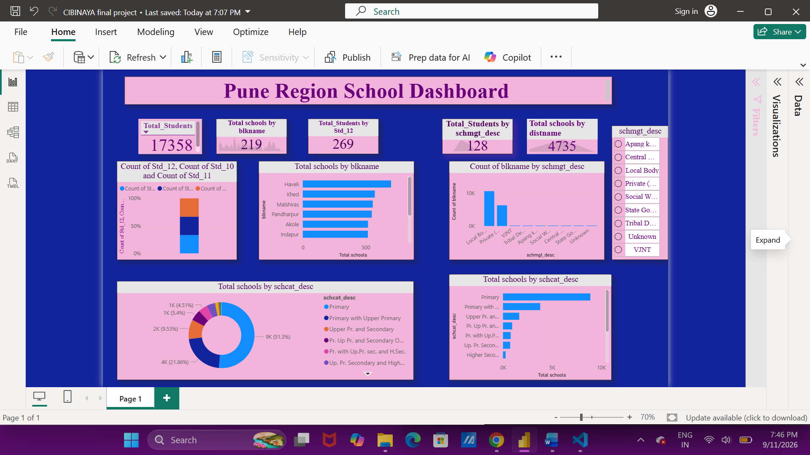

Task 7: Business Insights & Recommendations
- Specific management types (such as Local Body and Private management) hold a major share of educational administration compared to specialized government boards.
- Distribution patterns show that urban and semi-urban clusters (like Haveli) have significantly higher school densities and enrollment numbers than remote rural blocks.
- There is a noticeable decline in institutional proportion and student retention as students transition from primary and upper primary levels toward higher secondary grades.
- Top-performing blocks like Haveli and Khed manage a disproportionately high volume of schools and students, acting as the primary administrative hubs of the region.
- Early-stage grade levels account for the highest student volume capacities, which eventually streamline into smaller cohorts in higher classes.
- Blocks such as Haveli and Khed stand out for having the highest school counts, largest student populations, and densest infrastructure.
- Smaller or remote blocks show lower school counts and smaller average school sizes, indicating restricted institutional outreach.

Recommendations:
- Allocate infrastructural funding and teaching staff proportionately to lower-performing, remote blocks rather than concentrating them entirely in urban centers.

- Introduce targeted student retention schemes and upgrade select upper primary facilities to higher secondary levels to prevent the sharp drop-off in senior grades.

